**Assignment: See it, correct it, now make it**

**Website**

<https://danny1401.github.io/See-it_Correct-it_Make-It/>

or

<https://danny1401.github.io/See-it_Correct-it_Make-It/index.html>

**The Partner Group**

|  |  |
| --- | --- |
| **Name** | **Student number** |
| Danny Thinh Tran | s354409 |
| Kunwar Karan Singh | s235371 |

**The barriers from the website “*University of Advancing Technology”***

* From what I can see in the design is that there seems to be no sort of borderlines or not spaces between the elements so it feels like it’s too much sometimes. We can’t really feel the flow of how the elements are connected, but rather the fact that the elements are pushing each other for more room and attention.

***Solution:*** *Open up for more room between the elements or change their positions to other places so it’s easier to take in all the information from the website.*

* 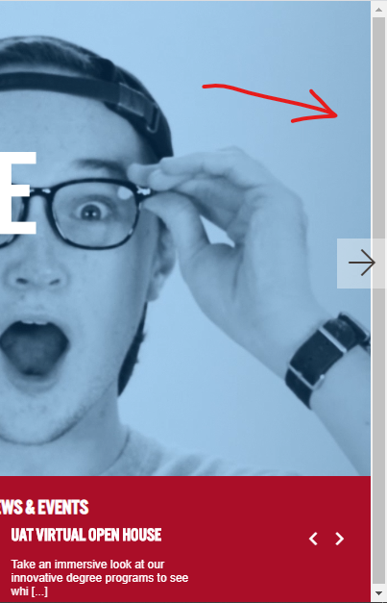There seems to be a misplaced scrollbar on the homepage which doesn’t have a purpose for anything on the site. Looking through the pages of the website from Google Chrome, it seems that the scrollbar only appears on the homepage, but I don’t know if it’s the same with the other browsers.

***Solution:*** *Remove the scrollbar.*

* 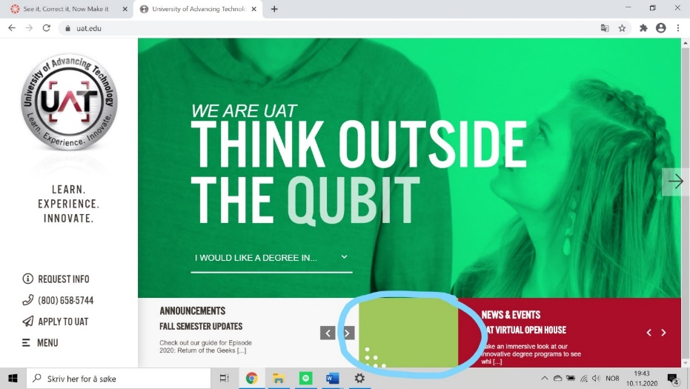The green box in the middle doesn’t seem to lack any purpose so it takes up some unnecessary space on the website. The color doesn’t seem to fit in that much either.

***Solution:*** *Remove the green box.*

* 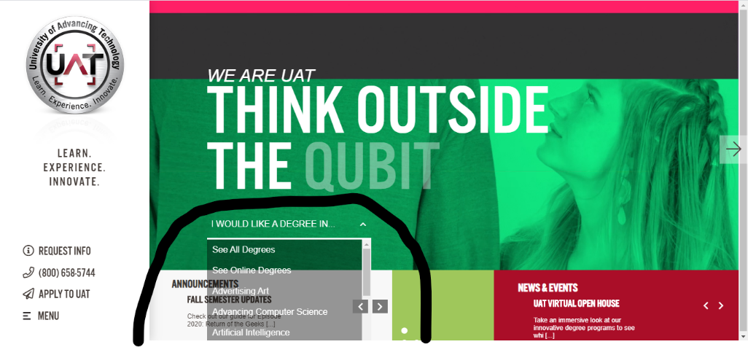There seems to be a little dropdown button in the moving image at the homepage. At first, I didn’t notice it because I thought it was a part of the video, but after looking through how it works, I realized that it would be better off if it was placed somewhere else.

The dropdown function seems to overlap under website too, since we can’t see the last option – Virtual Reality. The transparency doesn’t seem to fit in either with the design.

***Solution:*** *Change the whole idea of the dropdown to something that makes it easier to find the different degrees and place it under the page.*

* The boxes which shows announcements and news, should be placed somewhere else since they don’t really fit in with the moving image on top. Their functions don’t show a lot of information either since they just work as links to other pages with more stable information.

***Solution:*** *Place the boxes under the page with a cleaner way to look at the information. Since it’s just links, they would be better off as buttons.*